

User Manual

Bryan Davis, Robert Rotaru, Matthew Shafran, Brian Tardif | CS 410 | December 10, 2015

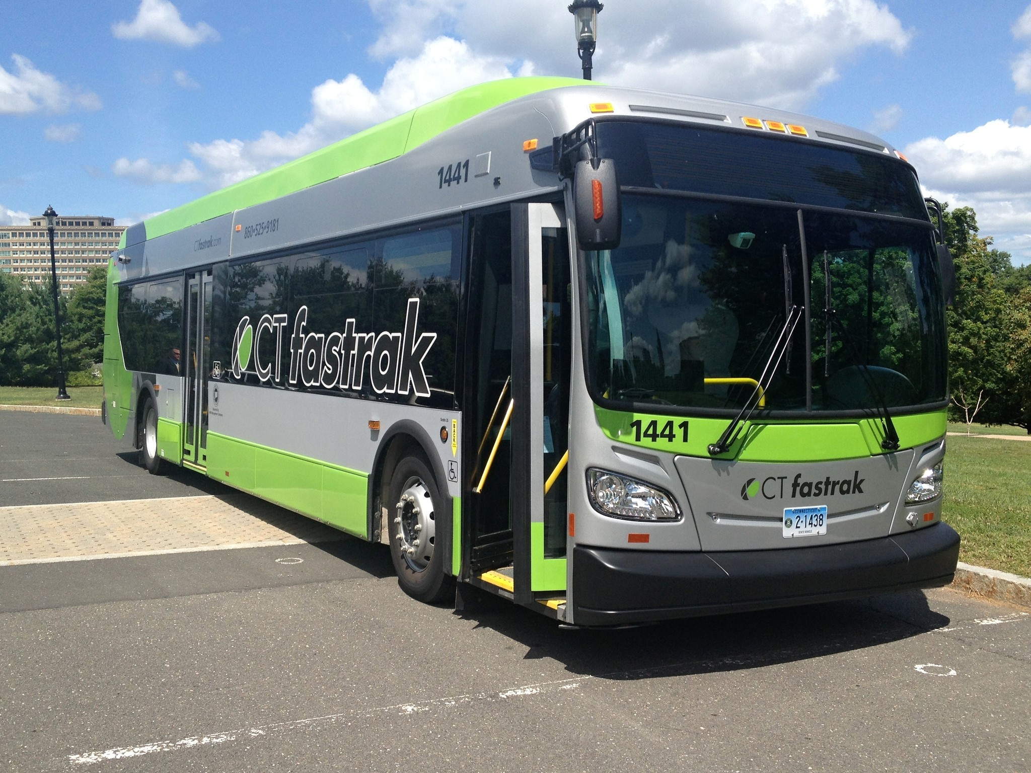

Contents

Getting Started 2

Main Features of the System 2

Viewing Buses and Routes 3

Toggle Buses 3

Toggle Routes 4

Buses and Routes 5

Getting Bus Information 5

Getting Stop Information 6

Planning a Trip 7

Entering a Destination and Using Current Location 7

Detailed Information about Bus and Bus Stop 8

Entering an Origin and a Destination 9

Detailed Information about Bus and Bus Stop 10

Determining the Best Route 10

Having a Route Composed of Multiple Buses and Routes 11

Calculating Walking Distance 12

Miscellaneous 13

Bus and Route Status Updating 13

Technical Usage 13

# Getting Started

In order to begin using our CTFastrak application, log into our site at http://matthew-shafran.github.io/CS410-CTFastrak/App/. This will bring you to our home screen where you will be able to interact with the system. The application will automatically determine your location and set you on the map. From here you can begin interacting with the application in a few different ways. The application requires an internet connection.

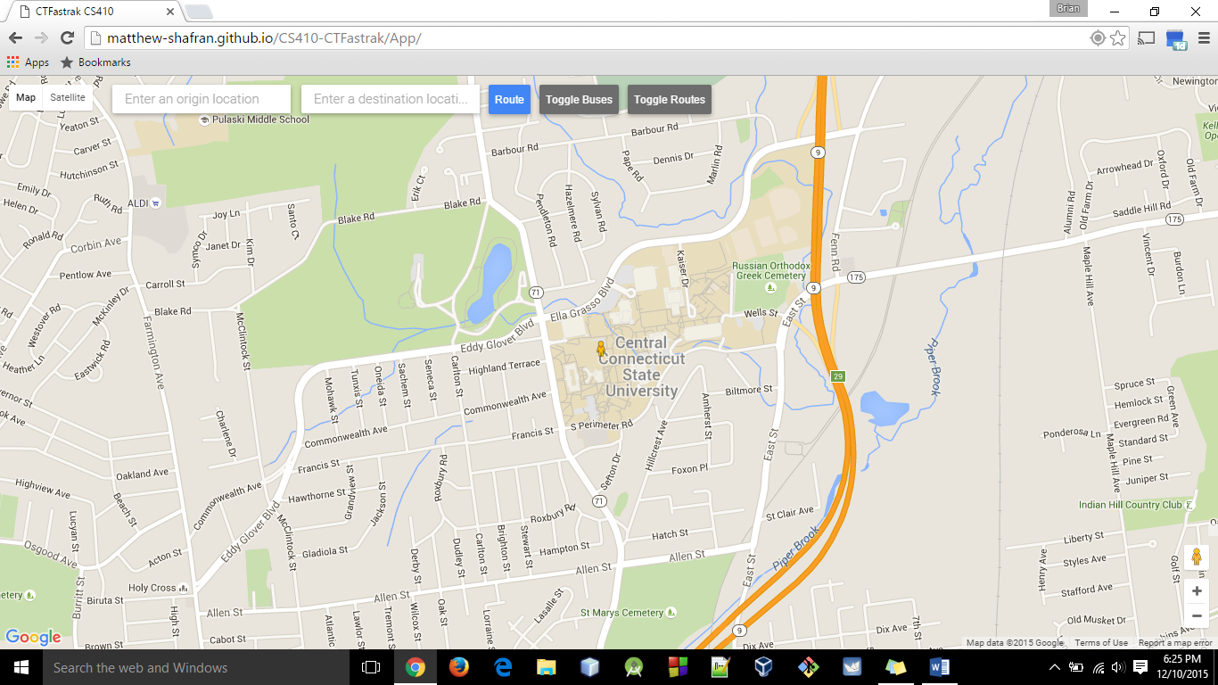

Figure 1: Initial Application Screen

### Main Features of the System

There are three main features of this CTFastrak Transit Application.

* A traveler is able to retrieve current information about the system of buses and routes
* A traveler is able to get the nearest bus terminal location based on their current location and their desired location
* A traveler is able to set a starting location and destination location and get the bus route that would take them there in the most efficient manner.
* A traveler is able to access information about a route. When the user clicks a bus, the route and all stops are displayed. The traveler can then access information about the bus, the individual stops, and the route as a whole.
* A traveler is able to construct a route that is composed of multiple buses, routes, and is displayed appropriate arrival and departure times related to their specific needs.

# Viewing Buses and Routes

The CTFastrak application enables the user to display all routes and all buses on the screen for viewing. There are two buttons located at the top of the screen which enable the user to access this functionality.

### Toggle Buses

Clicking the *Toggle Buses* button loads all buses that are currently in service and displays them on the screen.

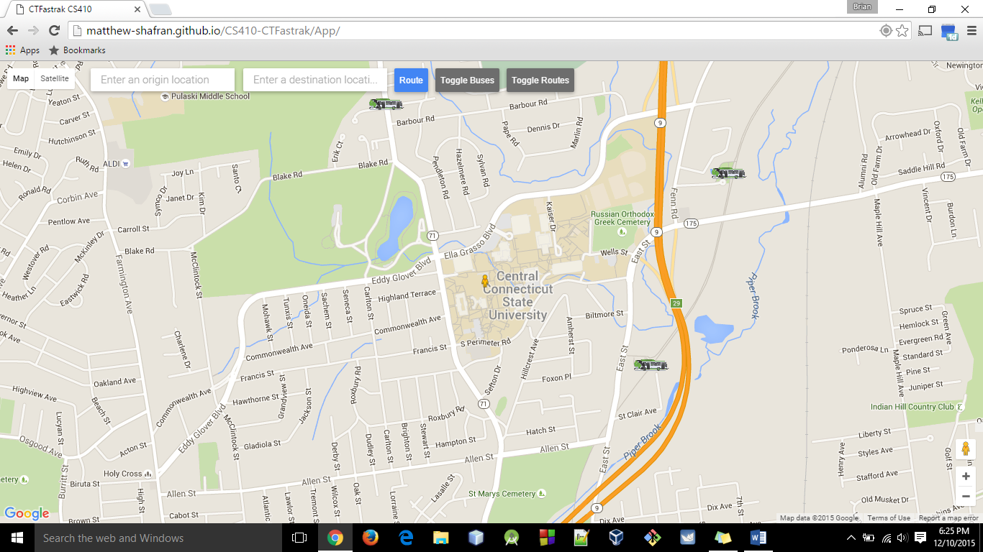

Figure 2 Displaying Buses

### Toggle Routes

Clicking the *Toggle Routes* button loads all routes of all buses that are in service and displays them on the screen.

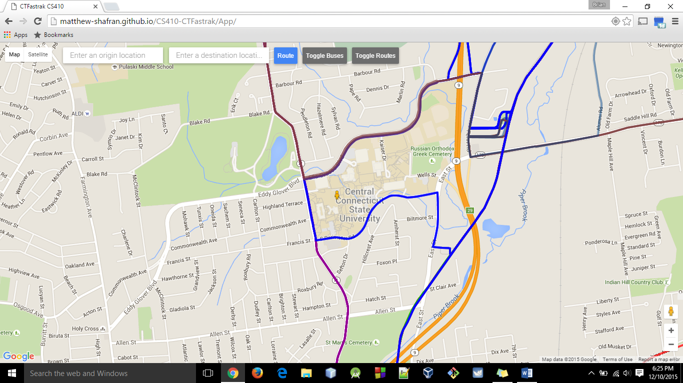

Figure 3 Displaying Routes

# Buses and Routes

### Getting Bus Information

When a clicks on a bus, the bus route along with the positions of the stops will appear on the map. A tooltip will also appear giving the user information about the bus: the bus number, the next stop, and the time the bus will arrive at this stop.

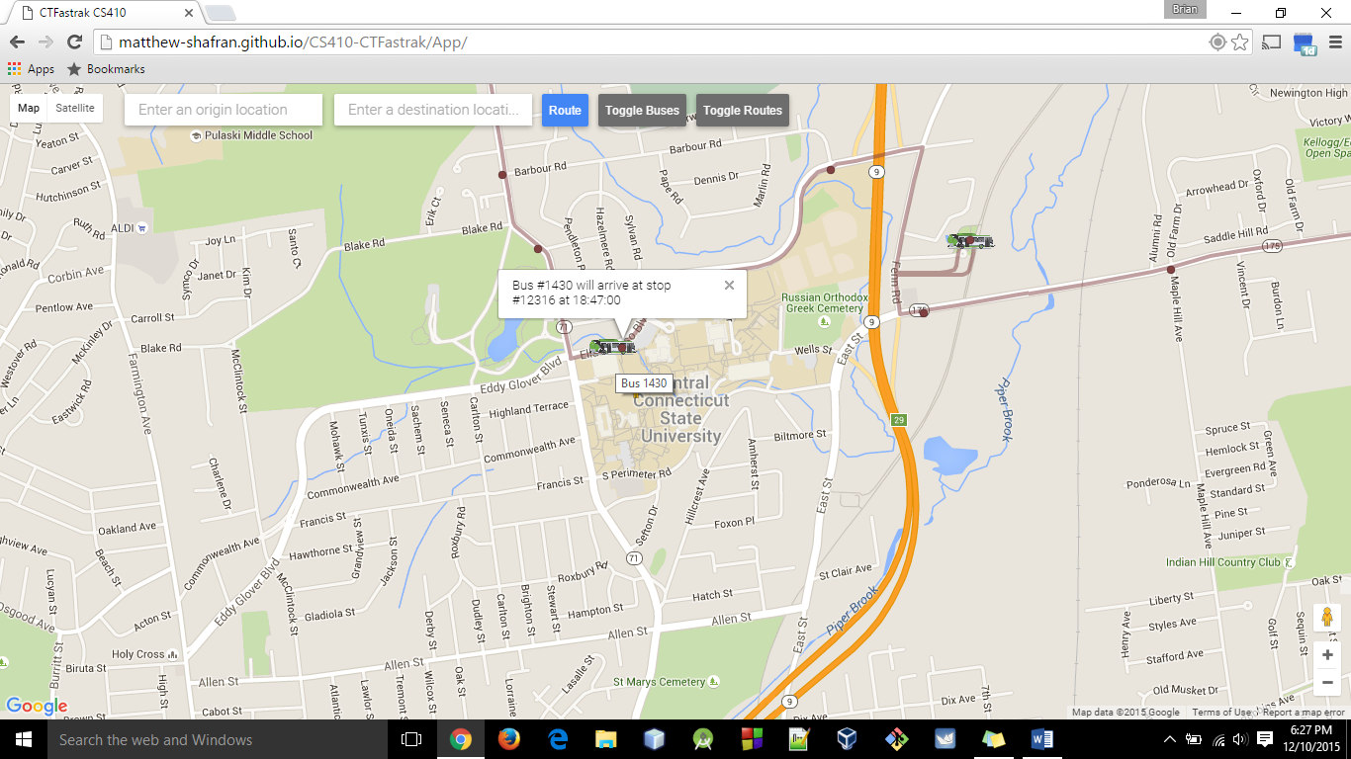

Figure 4 Display Bus Information

### Getting Stop Information

If you hover over a stop on the route of the bus you have selected, a tooltip will appear displaying the bus number, and pertinent information regarding the bus and stop: the stop number and the time the bus will arrive at this stop.

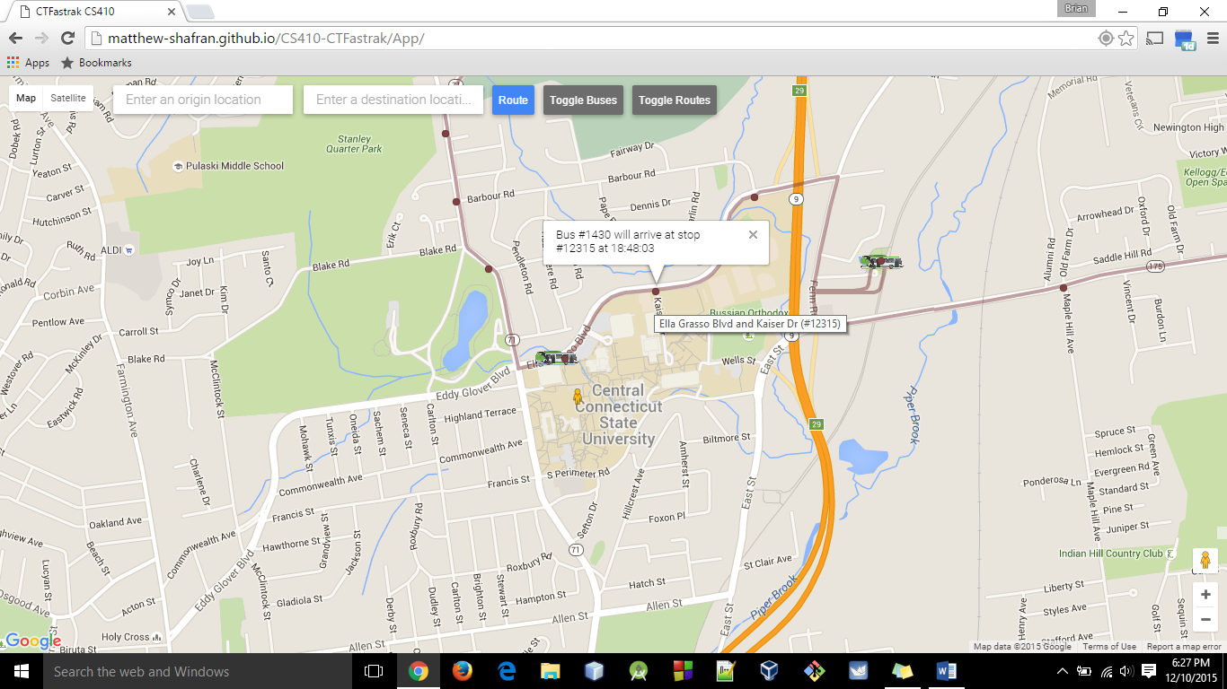

Figure 5 Display Bus Stop Information

# Planning a Trip

### Entering a Destination and Using Current Location

If a user would like to find the best bus route to a specific destination, the user can enter the address of the destination in the *Enter a destination location* input box and press *Route*. The application will then calculate the best route, and print the route in a solid line. The application will automatically set the starting point as the current location (unless it is specified otherwise). The application will also set walking directions to the nearest stop that the user can catch the upcoming bus.

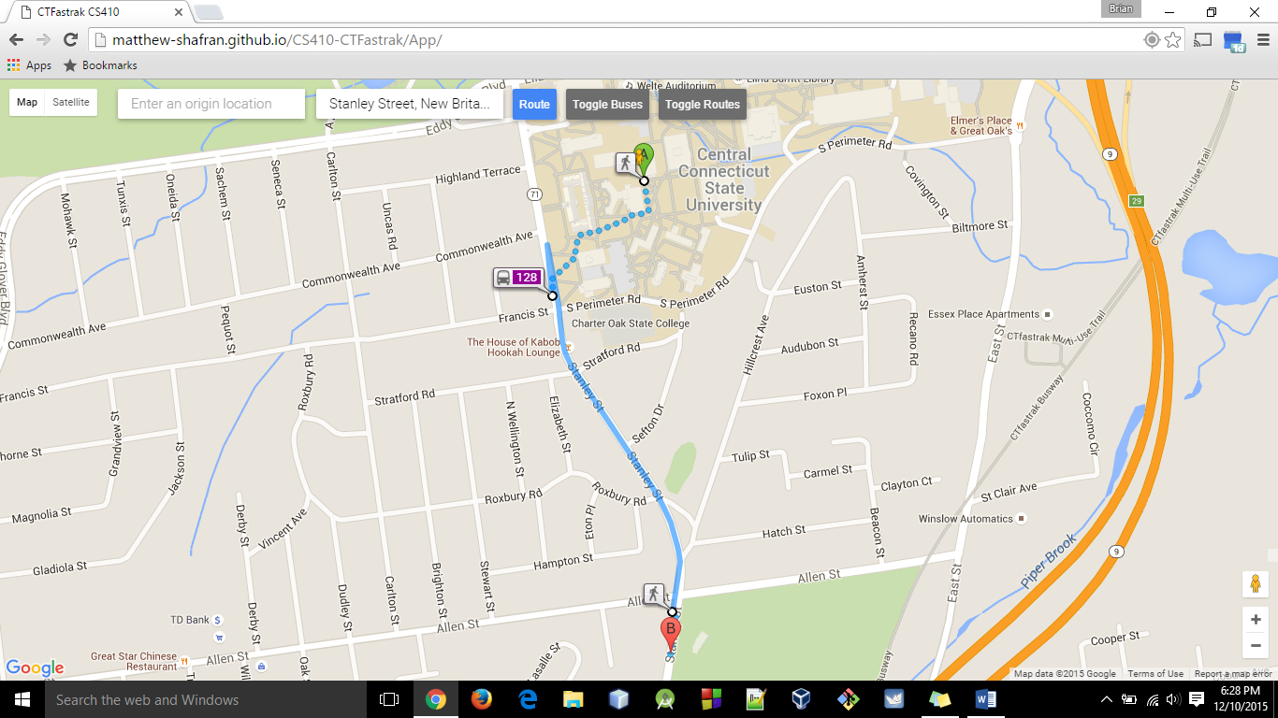

Figure 6 Calculate Route by Adding a Destination

### Detailed Information about Bus and Bus Stop

Additionally, the user will be displayed the bus number, the departure time of that bus from that stop, and the arrival time at the next stop by simply clicking on the stop.

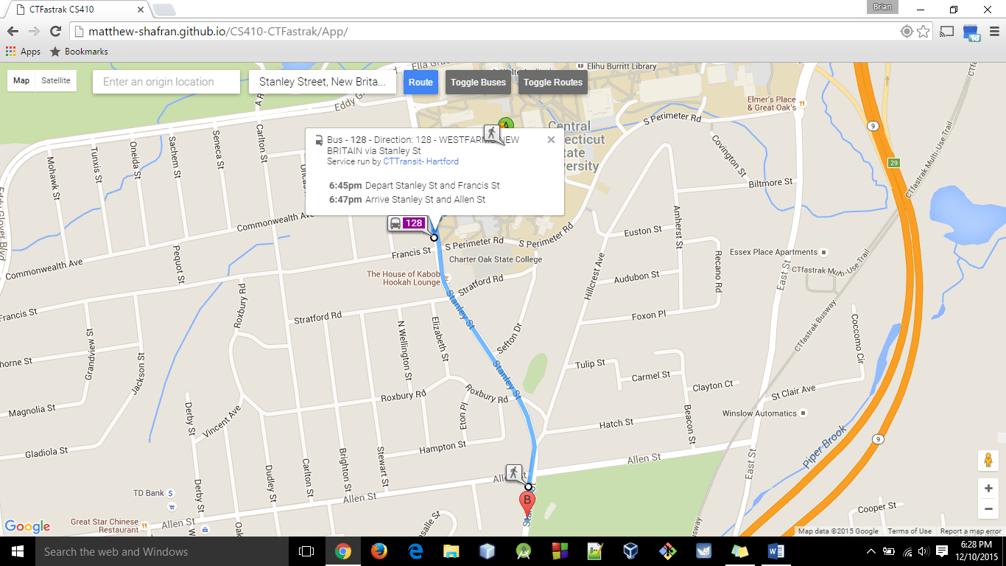

Figure 7 Additional Information Pertaining to Bus and Stop

### Entering an Origin and a Destination

If a user would like to find the best bus route to a specific destination from a specific origin, the user can enter the address of the destination in the *Enter a destination location* input box, the address of the origin in the *Enter an origin location*, and press *Route*. The application will then calculate the best route, and print the route in a solid line. The application will automatically set the starting point as the current location (unless it is specified otherwise). The application will also set walking directions to the nearest stop that the user can catch the upcoming bus.

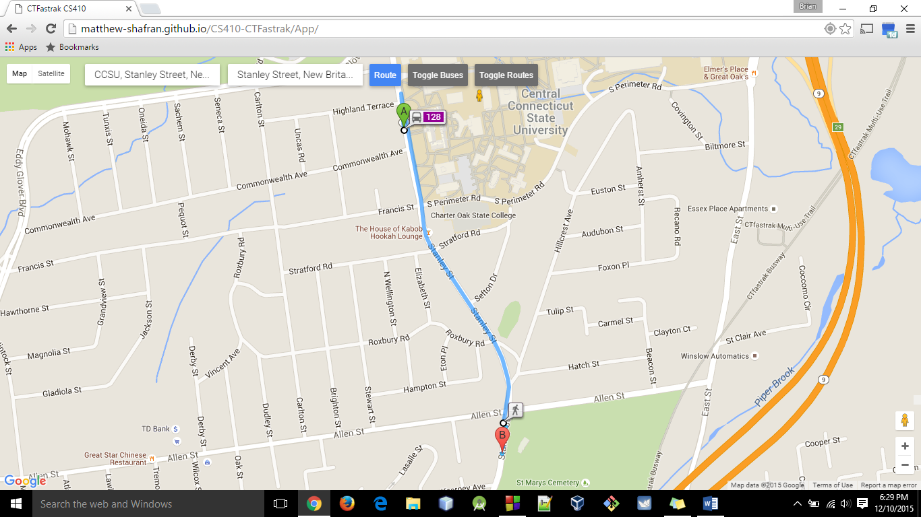

Figure 8 Calculate Route by Adding Origin and Destination

### Detailed Information about Bus and Bus Stop

Additionally, the user will be displayed the bus number, the departure time of that bus from that stop, and the arrival time at the next stop by simply clicking on the stop.

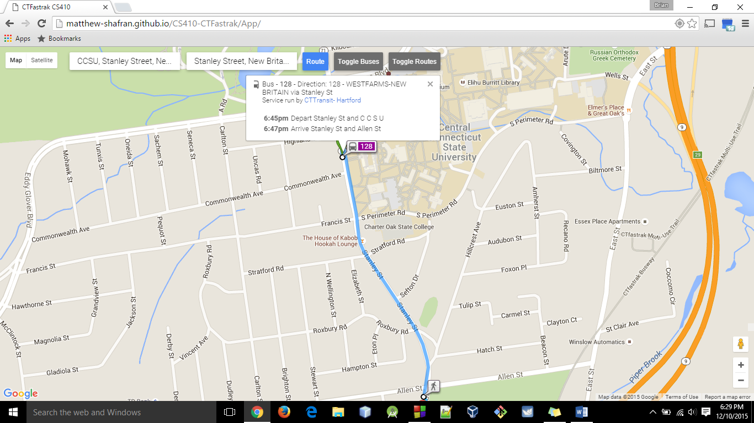

Figure 9 Additional Information Pertaining to Bus and Stop

### Determining the Best Route

There may be multiple routes and buses that will get a traveler from one point to another. This application will automatically calculate the fastest route based on current information available to the system. Because other routes will get the traveler to the destination in a longer period of time, only the optimal route will be displayed to the traveler.

### Having a Route Composed of Multiple Buses and Routes

In the case that a route will consist of combining two different buses and routes, the application will display the applicable bus numbers as well as the information about changing buses. The route will reflect the time it will take to take the first bus in its entirety, propose an appropriate junction between this bus and the next, and complete the route with subsequent buses.

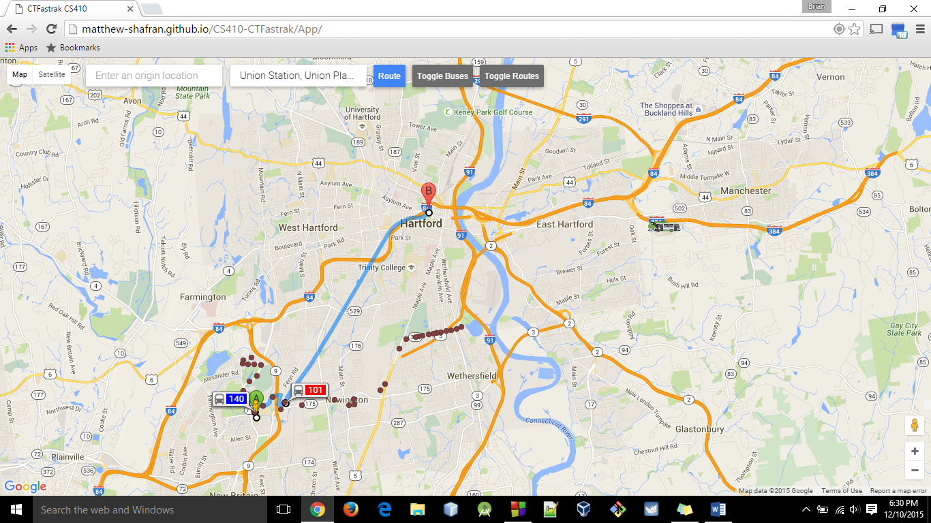

Figure 10 Calculate a Distance with More Than One Bus

### Calculating Walking Distance

If a bus stop is different than the location of the user, the user can click on a stop and the application will calculate the walking directions that the user needs to follow to get to the stop. This is effective because the user can plan not only the actual bus transit, but also the strategy to get to the particular bus stop where their transit will begin.

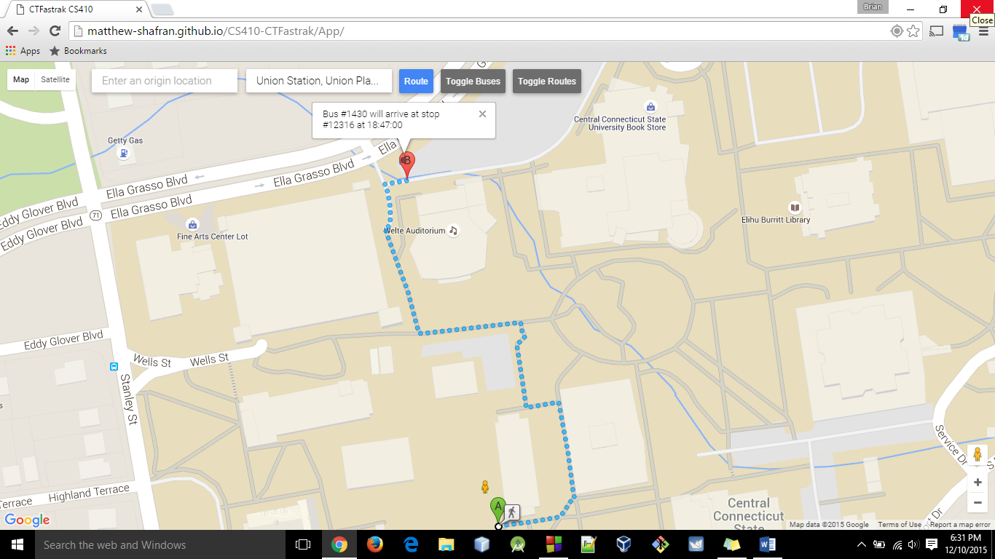

Figure 11 Calculate Walking Directions to Stop

# Miscellaneous

### Bus and Route Status Updating

The buses and routes are automatically updated with the CTFastrak API. Therefore the traveler that is using this application is not responsible for downloading or updating anything in order to have the latest information relating to stops and buses.

### Technical Usage

This application relies on the CTFastrak API to provide information related to the complete grid of buses and stops. It also provides information regarding the current locations of the buses and any important status updates related to the buses, routes, and system.